Project Design Phase-II
Data Flow Diagram & User Stories

Date | 27 June 2025
Team ID | LTVIP2025TMID34066
Project Name | SmartSDLC – AI-Enhanced Software Development Lifecycle
Maximum Mark | 4 Marks

Data Flow Diagrams:
A Data Flow Diagram (DFD) is a traditional visual representation of the information flows within a system. A neat and clear DFD can depict the right amount of the system requirement graphically. It shows how data enters and leaves the system, what changes the information, and where data is stored.
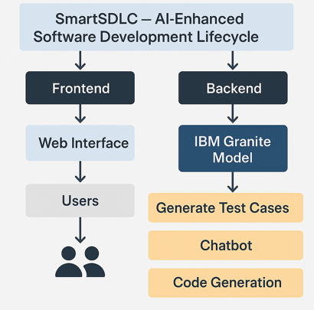
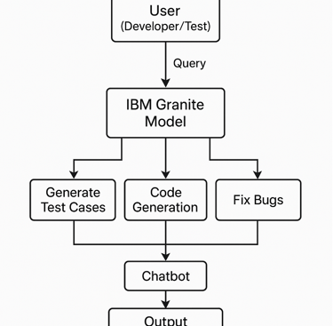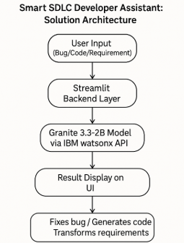

User Stories
- System Administrators focus on system reliability and continuous improvement through monitoring and testing of AI models and sensor data.

User Type | Functional Requirement (Epic) | User Story Number | User Story / Task | Acceptance criteria | Priority | Release
developer | Bug Fixing | USN-1 | As a developer, I want to automatically fix bugs in my code so I can save time and reduce errors. | The assistant suggests or applies valid fixes and shows improved functionality. | High | Sprint-1
 |  | USN-2 | As a developer, I want to generate boilerplate or functional code in my preferred language. | The assistant generates syntactically correct and logical code based on user input. | High | Sprint-1
 |  | USN-3 | As a developer, I want to transform natural language requirements into structured development tasks. | User sees structured output like user stories or pseudocode that matches the input requirement. | Low | Sprint-2
 |  | USN-4 | As a developer, I want to automatically generate unit and integration test cases for my code. | The assistant generates test cases relevant to user code and logic. | Medium | Sprint-1
 | Login | USN-5 | As a user, I can log into the application by entering email & password |  | High | Sprint-1
 | Dashboard
developer |  |  | As a developer, I want to ask technical questions and get accurate, instant responses.
 |  |  | As a developer, I want my code or concepts to be explained clearly so I can learn and understand them.
Administrator

